CS691 – Computer Science, Fall 2021

Pace University



SYSTEM TEST PLAN

Inwood Bagels

Authors: Abhilash Gubbala, Brindavani Pathuri

Project Manager: Gaelle Gilles

Date: 12/2/21

**Table of Contents**

**1. TESTING SCOPE** **3**

**2. TESTING OBJECTIVES** **3**

**3. TEST PROCESS** **4**

**4. APPROACH TO SYSTEM TESTING** **5**

**Testing the Website:** **5**

**5. ENTRY/EXIT CRITERIA** **5**

a) Entry Criteria: 6

b) Exit Criteria: 6

**7. ROLES AND RESPONSIBILITIES** **6**

**8. TEST CYCLES AND SCHEDULE** **7**

**9. RISKS AND CONTINGENCIES** **7**

INTRODUCTION

The purpose of this document is to provide the stakeholders of the Inwood Bagels website (inwoodbagelsny.com) a clear understanding of the scope, objectives, and approach to performing the system testing. This document will cover the following topics:

* Environmental needs
* Entry and exit criteria
* Test schedule
* Roles and responsibilities
* Risk and Contingencies

This document will reference other documents such as:

* The Project Plan
* RCT
* Business Requirements

Please refer to those documents for a broader understanding of the project.

# 1. TESTING SCOPE

The Testing scope includes two perspectives: the functional scope, and the technical scope.

The functional scope includes the following modules for the Inwood Bagels website:

* Home Page
* Menu and Order
* Payment Preferences

Users should be able to have a good user experience in those modules mentioned above.

The technical scope includes the following architectural components:

* Web browsers like chrome and internet explorer
* The database - Firebase
* Web Server - Node.js

# 2. TESTING OBJECTIVES

The main goal of the test plan is to create documentation that explains how the tester can verify that the system is working as intended. This document will explain what needs to be tested, how to test it, and who is responsible. By creating a test plan, all team members will work together to share responsibility.

## *2.1 Core Features to be Tested*

According to the Inwood Bagels’ RCT, the core features to be tested are:

1. Registering New Customer User:
   1. Users should be able to:
      1. Add their name
      2. Add their email address
      3. Create a password
      4. Have the option to add a home address for delivery
2. Account Details
   1. A user should be able to see their profile details such as their name, password (hidden), email address, and delivery address (if added)
3. User Login
   1. A user should be able to log in with their chosen email and password
4. View Menu
   1. A user should be able to view the menu
5. Choose Menu Item
   1. A user should be able to choose a menu item
6. Choose Delivery Method
   1. A user should be able to choose between picking up their food in-store or getting their food delivered
7. Display Price
   1. A user should be able to view the menu prices of items being displayed in the menu
   2. A user should be able to see the total prices at checkout

*2.2 Non-Functional Features to be Tested*

According to the RCT, the non-functional features to be tested include:

1. Usability:
   1. Easy navigation
   2. Accessing website through multiple browsers (i.e. Google Chrome, Edge, Firefox, Safari)

*2.3 Features not to be Tested*

The features that won’t be tested during the semester of Fall 2021, include the following that is noted in the RCT (by module):

1. Home Page
   1. User Support
2. Menu & Order
   1. Order Placed
3. Payment Preferences
   1. Select Payment
   2. Pay online / in person
   3. Payment completion
4. Order management
   1. Order received
   2. Prepare Order
   3. Order completed
5. Delivery Management
   1. Notify Order Status
   2. Notify of delivery
   3. Retrieve / Receive order
6. This includes the crosscutting concerns for the features mentioned above, and any other crosscutting concerns not noted to be tested (mentioned in the RCT). Non-functional features, such as security, will also not be tested this semester, as it is out of scope.

# 3. TEST PROCESS

The process of testing includes the phases:

* Test planning
* Test design
* Test preparation
* Test execution
* Test reporting

This process will find any bugs within the application. These phases are described below:

1. Test Planning Phase: This is a detailed document that mentions the roles and responsibilities, deadlines, testing scope, and testing approach.
2. Test Design Phase: This phase involves identifying and designing test cases, and the requirements of each test case.
3. Test Preparation Phase: During this phase, the test environment is set up, the data is provided, and the software that is needed is installed.
4. Test Execution: During this phase, all of the planned tests are executed, and any defects found are reported. The goal is to test the stability of the system by validating the features mentioned in this test plan document.
5. Test Reporting: During this phase, stakeholders are provided with the completed test executions. What will be reported are any defects (low to critical), the status of each test execution, and the test exit criteria evaluation.

4. APPROACH TO SYSTEM TESTING

4.1 Approach to Functional Testing

Functional testing will be tested using black-box techniques, such as cause-effect graphing. Meaning testing will happen from a user’s perspective. It will be designed with the user in mind and executed as a user. This will include things like GUI functionality if the signup button takes a user to a signup page. This testing will also take into consideration the requirements of the business mentioned on the Business Requirements Document.

4.2 Approach to Non-Functional Testing

Non-Functional Testing will be tested the same way as Functional Testing will be tested, using the black-box approach. For example, a user should be able to view their account information. Meaning, after their information (i.e. email address, delivery address) has been sent to the database, it should be retrieved from the database and displayed on their account page.

5. ENTRY/EXIT CRITERIA

The entry and exit criteria will define the test execution of the Inwood Bagels website project. The intention of the Entry and Exit Criteria is to have an understanding of the test conditions and when the test executions should begin and end.

The entry criteria will let a tester know when to begin test execution. It will include the following:

* The module being tested has been produced (i.e. the website includes a Sign In section)
* The website has been deployed on a browser such as Chrome, Microsoft Edge, or Firefox.
* The test design has been completed
* The test specifications have been completed

The exit criteria will let a tester know when to end the test execution. It will include the following:

* All tests specified have been completed
* Any critical defects that arose have been solved
* All medium or low defects are solved
* A summary of the test has been completed and stakeholders are informed of the reports
* Once test execution is completed, the system will be ready for User Acceptance Tests

6. SYSTEM TEST ENVIRONMENT

To test the website, a laptop or a mobile device is needed. On that device, a browser should be installed to access the website. Below is a process view of the test environment:

Architecture Type: Application Architecture

View: Process View

Style: Client-Server Pattern

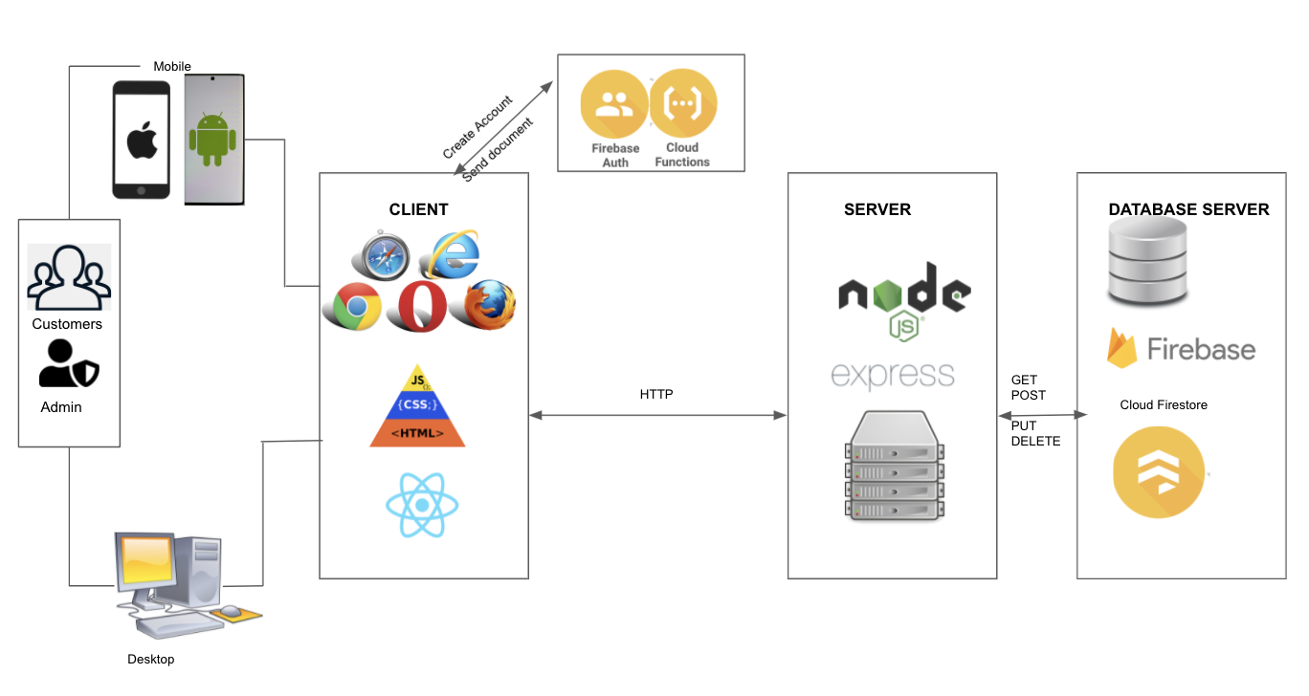

# 

# 7. ROLES AND RESPONSIBILITIES

The project roles involved in system testing include the following:

|  |  |
| --- | --- |
| **Project Role** | **Role Responsibilities** |
| Project Manager | Allocates the overall project timelines and assigns tasks to project team members. Complete test case for module Account Details |
| Lead Developer | Test case for module Choose Menu Item |
| Developer | Test case for module View Menu |
| Product Owner | Test case for module Register New User |
| DBA | Test case for module User Login |
| Lead QA Analyst | Prepared Test Plan Document and Test case for module Order Placed |
| Tester | Prepared Test Plan Document and Test case for module Display Price |
| Business Analyst | Test case for module Choose Delivery Method |

8. TEST CYCLES AND SCHEDULE

Cycle 1: The first part of testing will focus on:

* Allowing users to create their own account
* Allowing users to view the menu with prices
* Allowing users to log in to their account
* Allowing users to only select an item

Cycle 2: The second part of testing will focus on:

* Allowing users to see their account details
* Allowing users to choose a delivery method

9. RISKS AND CONTINGENCIES

Below describes the risks and contingencies that may occur during testing:

* Too few resources to test
* Lack of required software can cause a delay in testing
* The team not collaborating well, causing a negative impact on the progress of the test
* Misunderstanding of what needs to be tested
* Last-minute additions to already completed and already tested sections of the project
* Many defects that require a longer time to fix in order for the testing to be complete
* Any changes to test design that happen after test execution occurs and test reporting is completed